Transferring a real file from source node to destination node in WSN

In WSN file transfer, a file containing some information is provided as input to NetSim. This file is then read and set as payload for the packets sent from source to destination.

For the purpose a file named send.txt with some data is kept in the bin folder. During Simulation this file is read and this data is added as payload of the packet.

In the ZigBee project functions are written to read the data from the input file, set packet payload and to write the packet payload to the output file.

The following functions are added to the sensor.c file:

fnsendfile()

Reads the input file “send.txt” from the bin path and adds it as payload to the current packet.

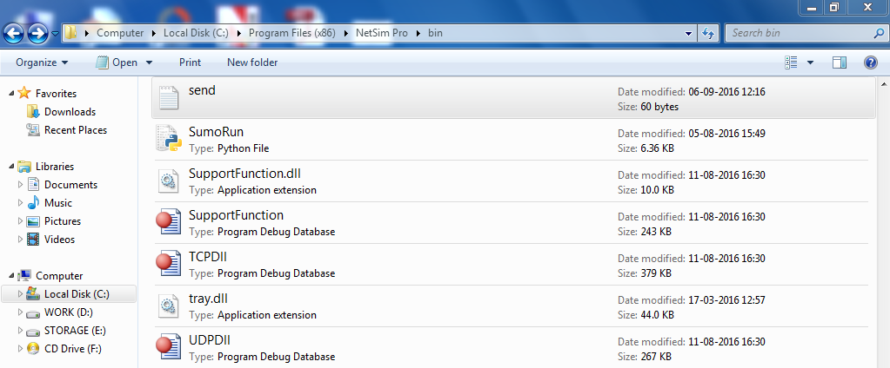

fnWriteFile()

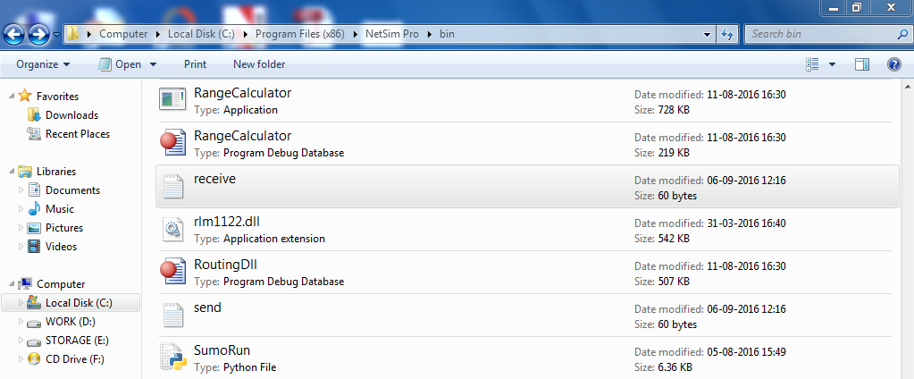Writes the contents of the current packet payload to the “receive.txt” file.

# Steps to transfer real file in WSN:

1. Open Simulation - WSN File Transfer folder and double click on the NetSim.sln file to open the project in visual studio.
2. Now right click on ZigBee project in the solution explorer and select Rebuild.

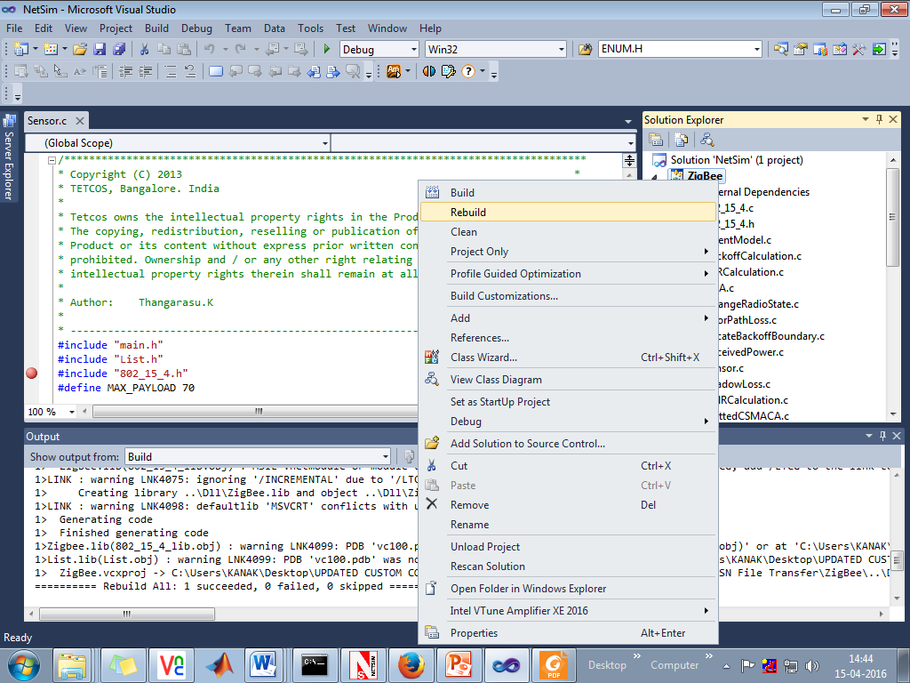

1. Now Copy the newly built libZigBee.dll from the DLL folder inside the Simulation – WSN File Transfer directory.
2. Create a file named send.txt with some file contents in the bin folder inside NetSim Installation Directory.
3. Now create a network scenario in WSN Network by dropping a sensor followed by a sinknode and an agent.

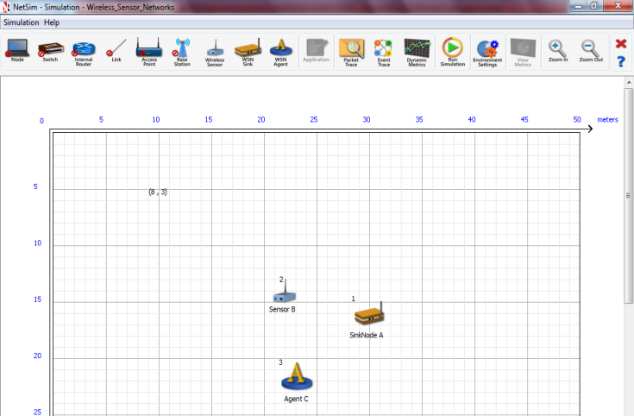

1. Run the Simulation.
2. Output file will be created in bin folder of NetSim with the name **receive.txt.**Due to retransmissions and errors, sometimes the output file is not reproduced correctly. To get exact file, user has to enable TCP (WSN works on UDP).